Handige code uit slides

Struct Ray

{

float3 O; // ray origin

float3 D; // ray direction

float t; // distance

};

vec3 Trace( Ray ray)

{

I, N, material = scene.GetIntersection( ray );

If ( material.isMirror )

return material.color \* Trace( ... );

Return DirectIllumination() \* material.color;

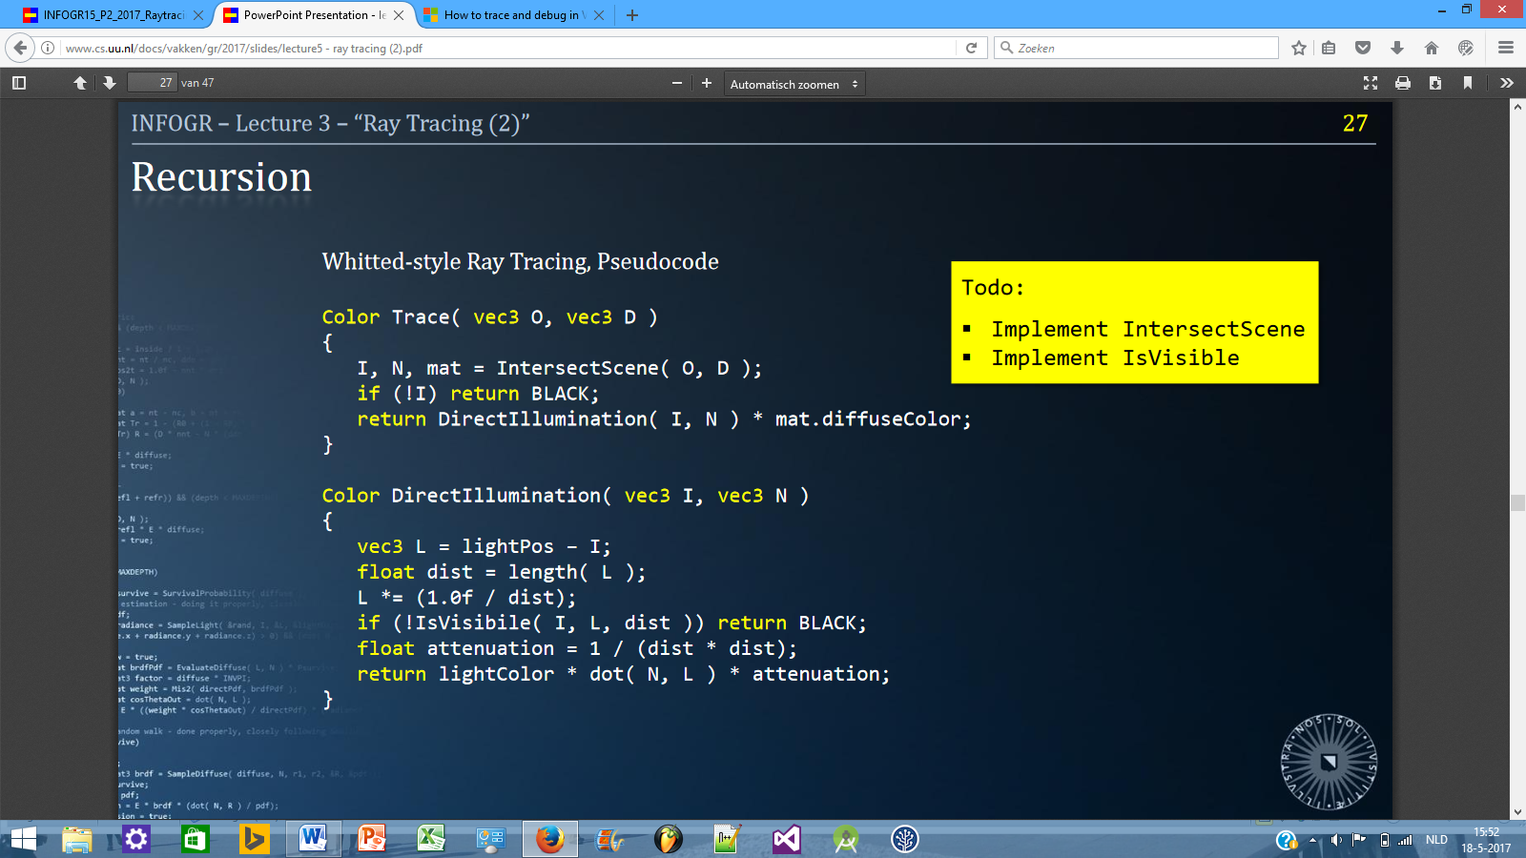}

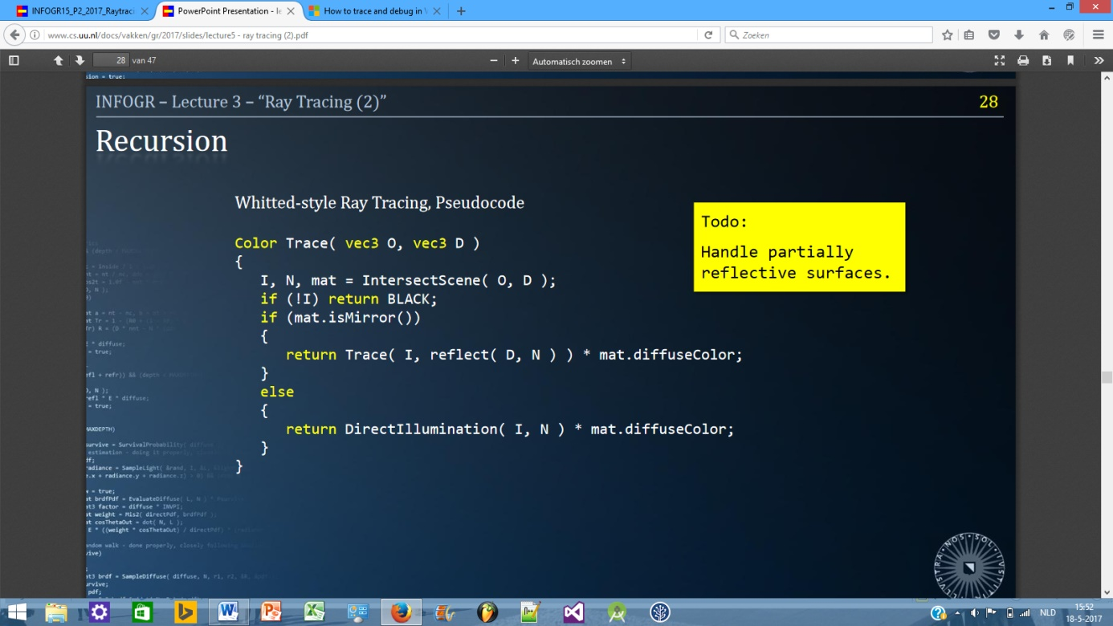

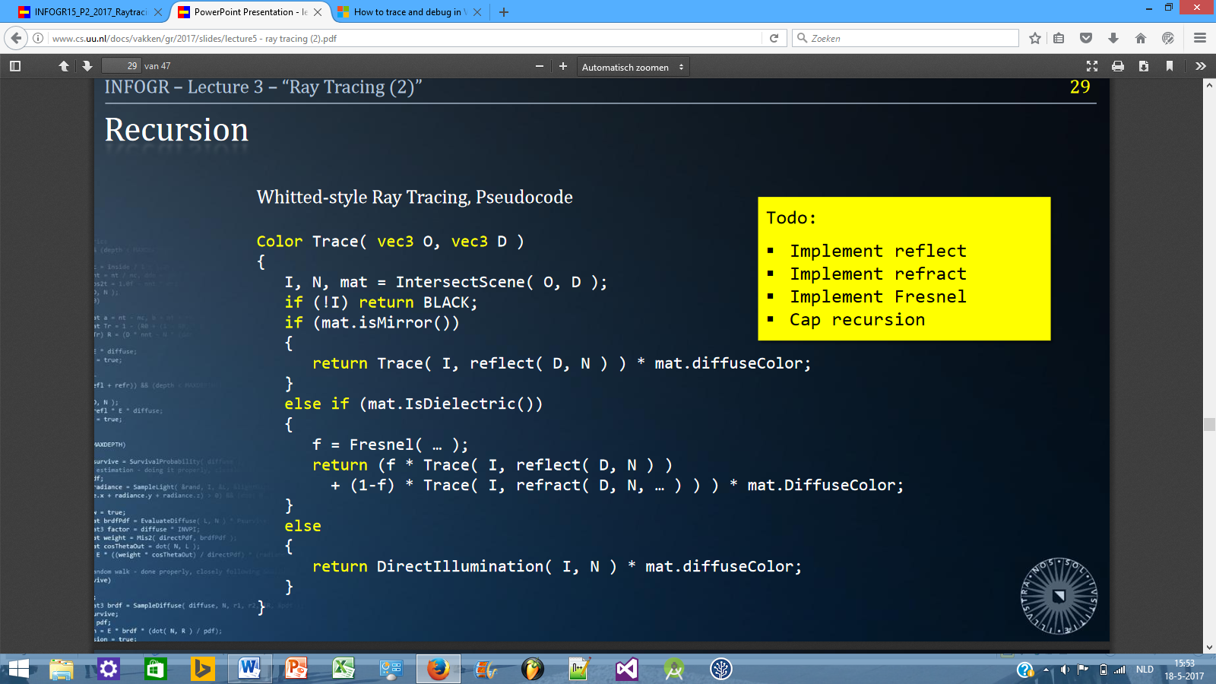

TX en TY

private int TX(float x)

{

x += (2 \* zoom) - centerX; //offset

x \*= (screen.width / 4); //scale

x = x / zoom; //zoom extra

return (int)x;

}

private int TY(float y)

{

y += (2 \* zoom) - centerY; //offset

y \*= (screen.height / 4); //scale

//zoom (higher zoom = zooming out)

y /= zoom;

//reverse the y

y = (screen.height - y);

return (int)y;

}